21-04-2025

Spring Boot DATA JPA



Dto:  
data transfer object -----------entity class

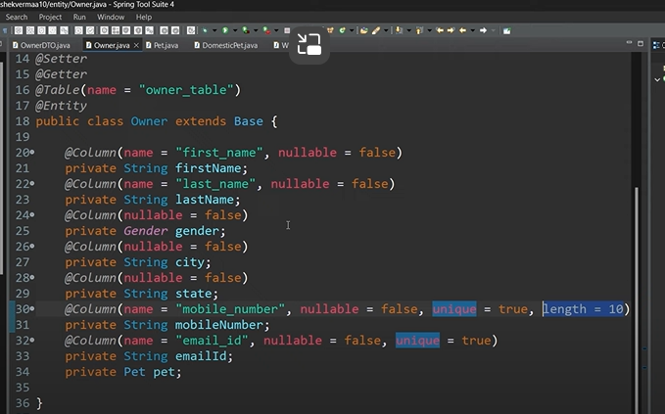

In Java, enum (short for enumeration) is a special data type that represents a group of constants. It is often used when you have a fixed set of predefined values, like days of the week, directions, or colors. Here's a quick example:

@enumerated(value=EnumType.String)

Here gender is enum

Spring mvc :

12/05/2025

Model view controller

Here model; is data

View ;application

Controller ; will get the in the form of http

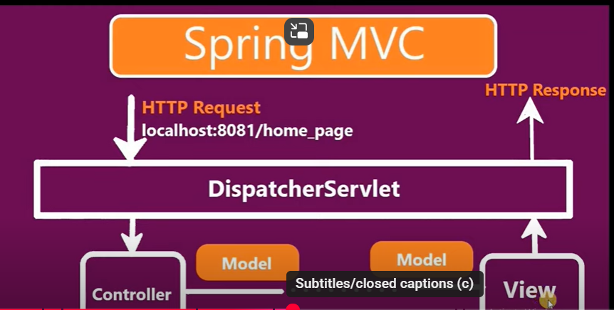

Here string consider cheyyali ante request body pettali

Here if u give jsp file need to create one folder it will be redirected the page

But here if u provide jsp file inside controller we need import tomacat jasperit will convert the servlet page other will download the file.

Need to check with tomcat server.

